**Week-08-Sorting Algorithms-Bubble and Selection**

Week 08-01-practice session coding

Reg no : 241801271

Name : sivagopika M

Q1)

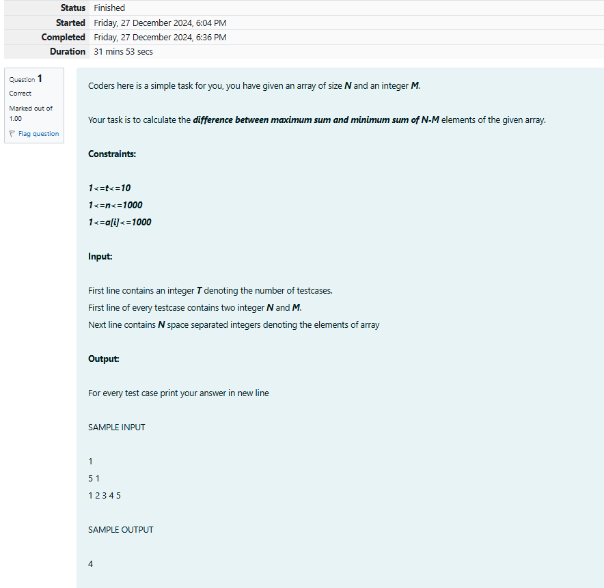

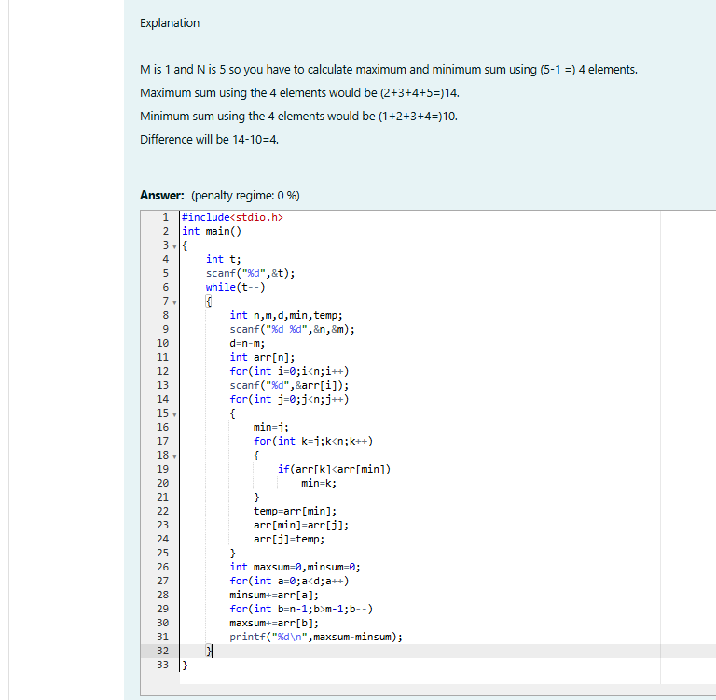

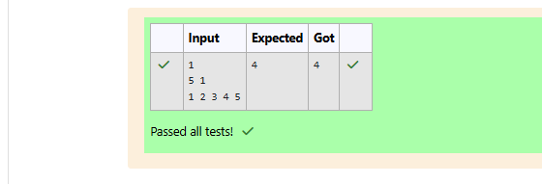

Week 08-01-practice session coding

Reg no : 241801271

Name : sivagopika M

Q2)

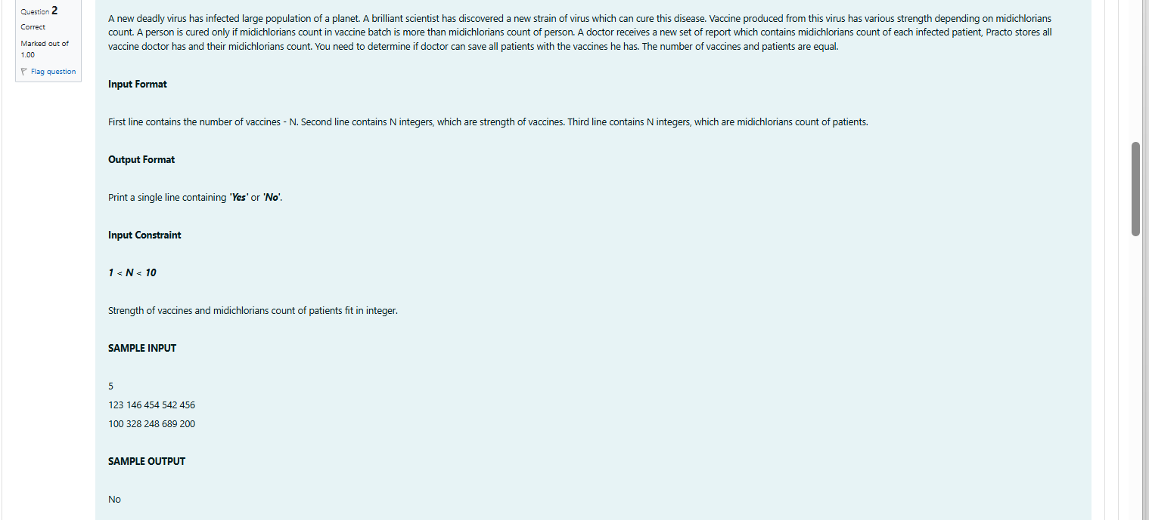

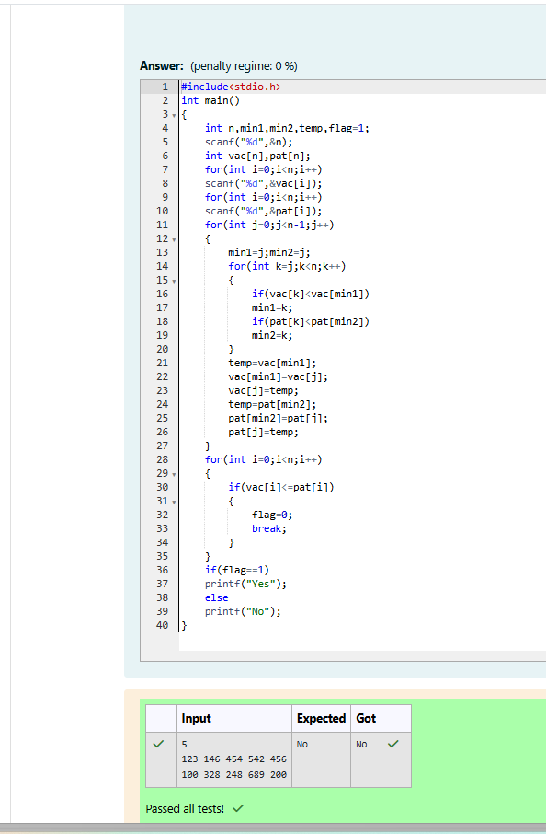

Week 08-01-practice session coding

Reg no : 241801271

Name : sivagopika M

Q3)

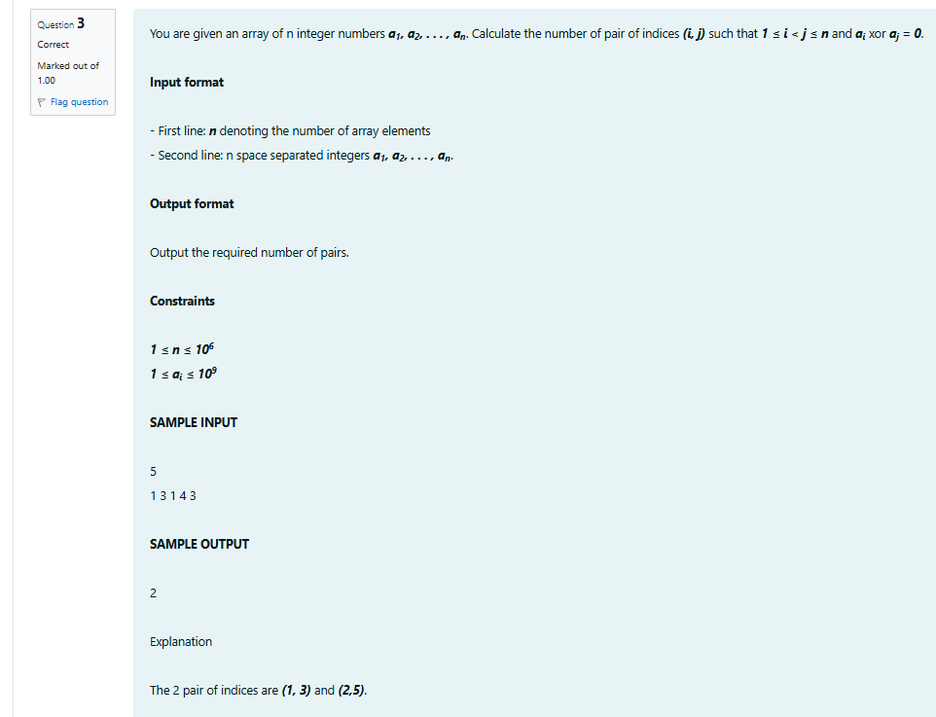

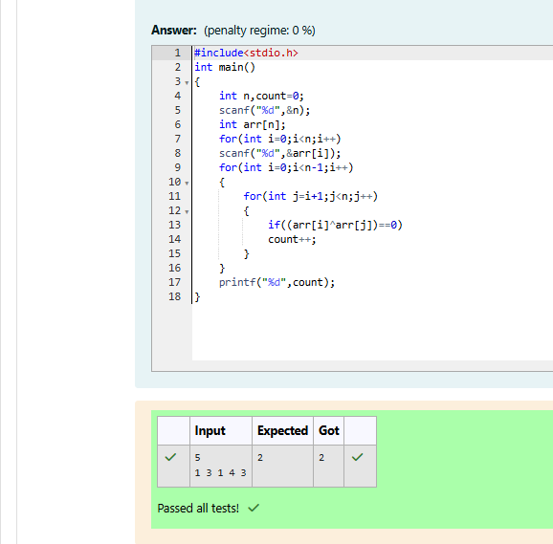

Week 08-01-practice session coding

Reg no : 241801271

Name : sivagopika M

Q4)



